After Your Fundraiser

Please send this completed form to Kares 4 Kids along with your money raised

in order for participating sponsors to receive proper credit for their donations.

Checks must be made to Kares 4 Kids.

**REMEMBER** – only donations that your market center receives AFTER all of your event

expenses are paid should be sent in as a Kares 4 Kids donation. Please refer to the

|  |  |  |  |  |  |
| --- | --- | --- | --- | --- | --- |
| Name of Person or Company | $ Amount | Cash, Check, or Square Transaction? | Check # if Applicable | Mailing Address for Tax Letter | Email |
|  |  |  |  |  |  |
|  |  |  |  |  |  |
|  |  |  |  |  |  |
|  |  |  |  |  |  |
|  |  |  |  |  |  |
|  |  |  |  |  |  |
|  |  |  |  |  |  |
|  |  |  |  |  |  |
|  |  |  |  |  |  |
|  |  |  |  |  |  |
|  |  |  |  |  |  |
|  |  |  |  |  |  |
|  |  |  |  |  |  |

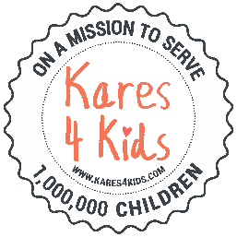*****Dual Sponsorship Guidelines*** sheet for more information.

Name of Event: ________________________________________ Date of Event: _______________________